**WELSH WATER**

**ANNOUNCEMENT OF PLANNED WORKS**

**HIGHWAY AFFECTED: A4075 DATE: FRIDAY 6TH SEPTEMBER 2024**

Welsh Water (WW) are carrying out essential work to the water network on the A4075, Martletwy.

This work is planned to start on Friday 6th September, and is anticipated to be completed by the end of the day.

Whilst this is the planned date and duration, it may change in the event of an emergency, or factors beyond normal control. Should the work need to be rescheduled or change in any way, WW will update the ‘In Your Area’ section of the website:

<https://www.dwrcymru.com/en/help-advice/in-your-area>

To carry out the work safely, there will be temporary two-way traffic lights around the working area. The location of the work is shown on the image below, although you can also view the exact position by visiting What3Words.com, and using the three words natural.flexed.thrillers

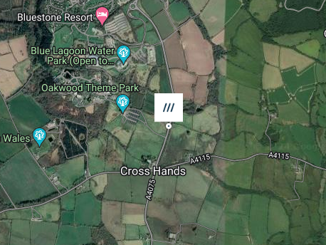

The work will be taking place near to the entrance to Oakwood Theme Park, and within the vicinity of other attractions. In this respect, WW have reached out to the local businesses to let them know what’s happening, sent text messages to those living in the area; to let them know, and how to sign up to receive updates.

It is not expected this work will impact the water supply to any nearby properties, although if anything changes, WW will let you know.

The work will be inconjunction with Envolve Infrastructure to get the work done from 7.30am on Friday 6th September, to complete the work as quickly as possible.